**LAB 7: Consider a network topology and IP address assignment of your choice and illustrate concept of HTTP, DNS & DHCP server setup in Packet Tracer.**

**Objective:** To configure and understand the HTTP, DNS and DHCP service using Packet Tracer

**Device used**

|  |  |  |  |
| --- | --- | --- | --- |
| **S.N.** | **Device** | **Model** | **Quantity** |
| 1 | PC | PC | 4 |
| 2 | Switch | 2960 IOS15 | 2 |
| 3 | Router | ISR4331 | 1 |
| 4 | Cable | Straight through | 9 |
| 5 | Server | PT-Server | 3 |

**Background**

HTTP:

HTTP (HyperText Transfer Protocol) is the protocol used to transfer hypertext between two computers. It provides a standard between a web browser and a web server to establish communication.

DNS:

The domain name system (DNS) is a naming database in which internet domain names are located and translated into Internet Protocol (IP) addresses.

DHCP:

DHCP (Dynamic Host Configuration Protocol) is a network management protocol used to dynamically assign an Internet Protocol (IP) address to any device, or node, on a network so they can communicate using IP.

**Topology**

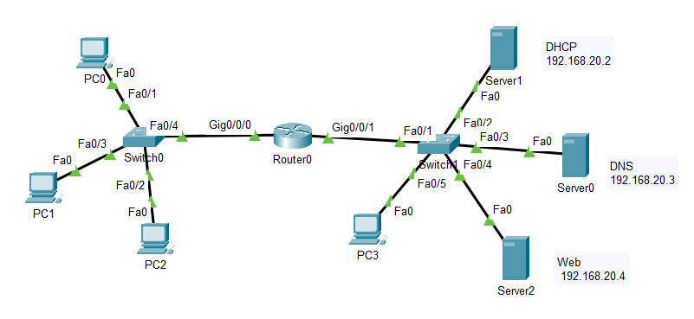

**IP Address Plan**

|  |  |  |  |  |  |
| --- | --- | --- | --- | --- | --- |
| **Device** | **Interface** | **IP** | **Subnet Mask** | **DNS Server** | **Default gateway** |
| Router 0 | gig 0/0/0 | 192.168.10.1 | 255.255.255.0 | Default | - |
| Router 0 | Gig 0/0/0 | 192.168.20.1 | 255.255.255.0 | Default | - |
| Server 0 | NIC | 192.168.20.3 | 255.255.255.0 | 192.168.20.3 | 192.168.20.1 |
| Server 1 | NIC | 192.168.20.2 | 255.255.255.0 | 192.168.20.3 | 192.168.20.1 |
| Server 2 | NIC | 192.168.20.4 | 255.255.255.0 | 192.168.20.3 | 192.168.20.1 |
| All PC will get the IP address from DHCP server dynamically. | | | | | |

**Procedure**

1. Switches are joined with a router
2. 3 PCs are joined with a switch
3. 3 servers and a PC is joined with another server
4. Assign the IP address to each server as shown in IP table.
5. Set up the DHCP Server as shown below

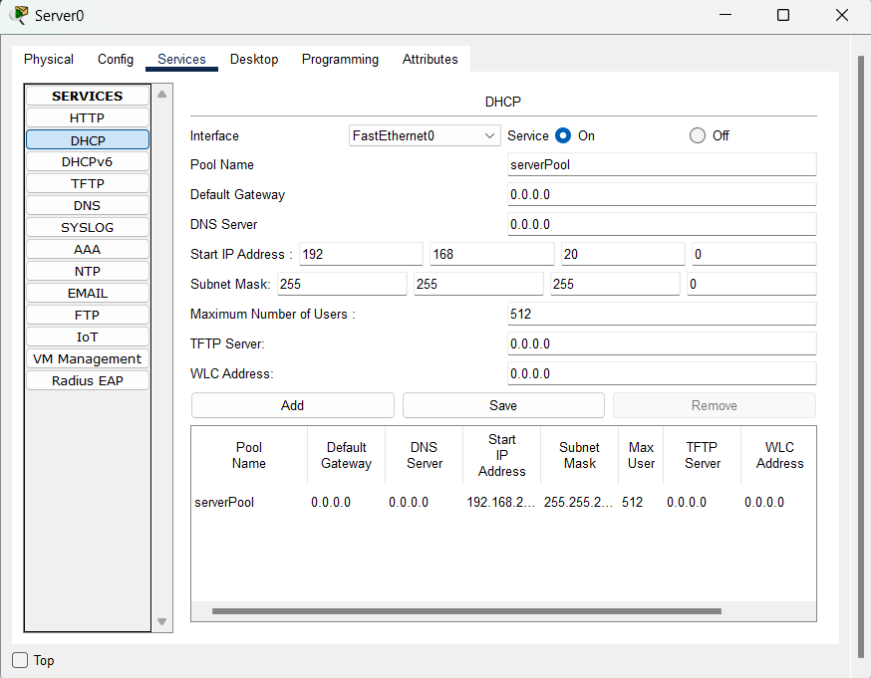

1. Set up the DNS Server as shown below

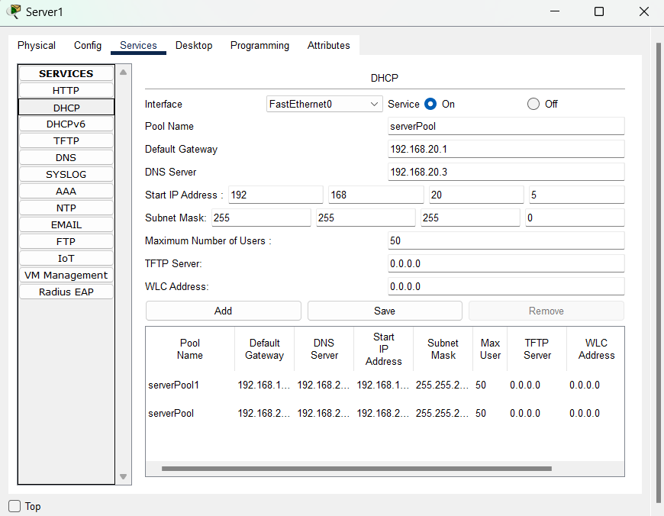

1. Set up the WEB Server as shown below

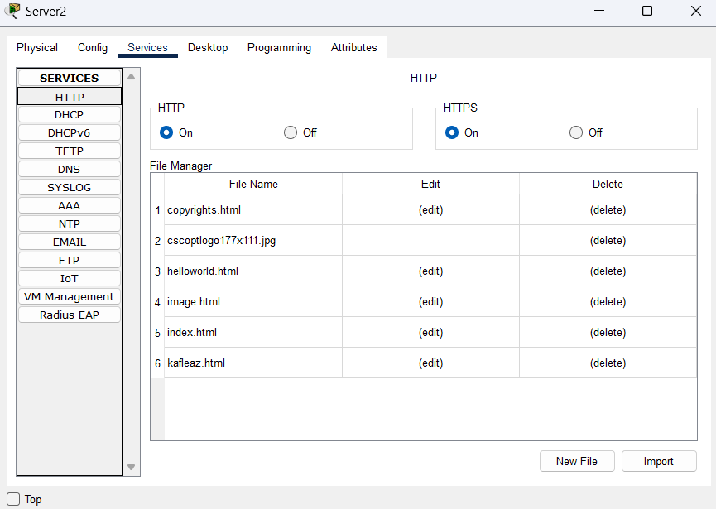

1. Setup the router interface as:

Router>enable

Router#configure terminal

Router(config)#interface GigabitEthernet0/0/0

Router(config-if)#ip address 192.168.10.1 255.255.255.0

Router(config-if)#no shutdown

Router(config-if)#exit

Router(config)#interface GigabitEthernet0/0/1

Router(config-if)#ip address 192.168.20.1 255.255.255.0

Router(config-if)#no shutdown

Router(config-if)#exit

**To forward broadcast message to DHCP server:**

Router(config)#interface gig 0/0/0

Router(config-if)#ip helper-address 192.168.20.2

1. Get the IP in each PC by selecting DHCP Option as: click on PC-> click on desktop tab and the select the DHCP then DHCP request sent to the DHCP server and server will assign the IP as shown below

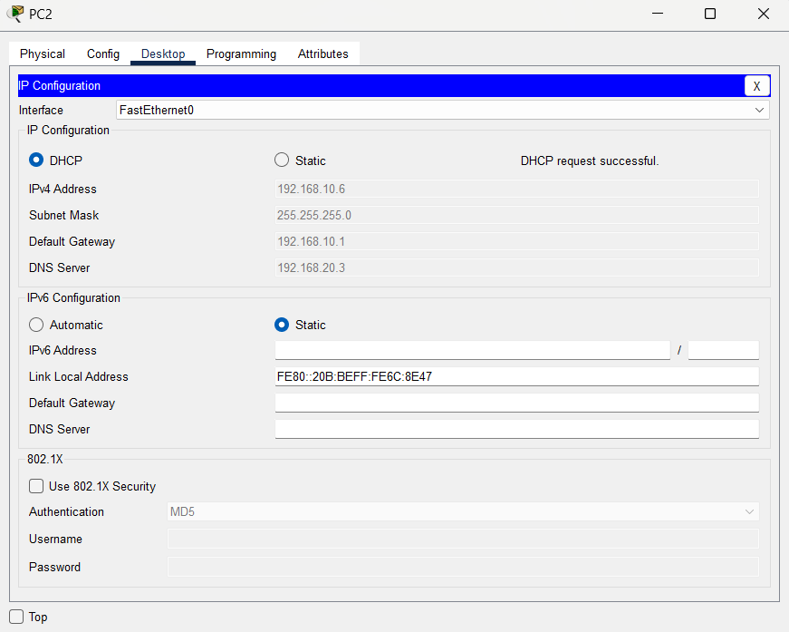

**Verification**

Click in any one PC select desktop tab select web browser and then enter tek.com.np then you will get the following response from the Web server after resolving domain name tek.com.np into IP address 192.168.20.4 by the DNS server

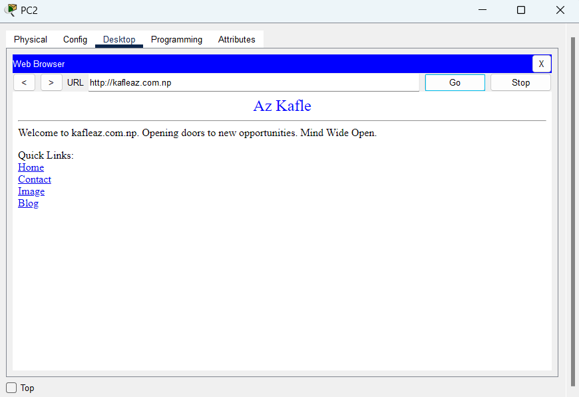

**Conclusion**

In this way we can setup DHCP, DNS and Web server in our network and these services works in close association as shown in this experiment.